EXAM013 Image Correction

Save all the images back onto this document

- Take this image and Square up the tilt so that the image is horizontal
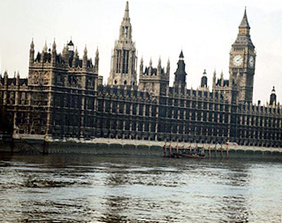

Save the image back onto this document

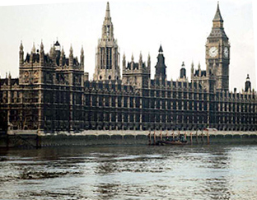

Use the crop tool and correct rotation

- Improve the colour of this photograph back to a natural colour
Save the image back onto this document
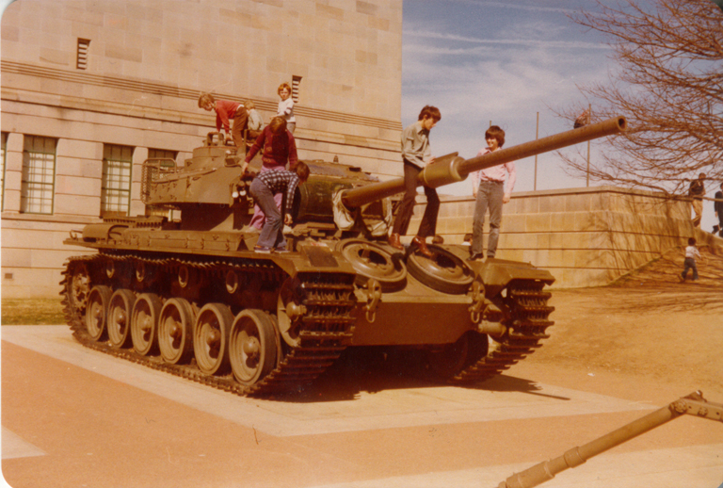

Use Levels and set each one individually R G B changing the range using the slider

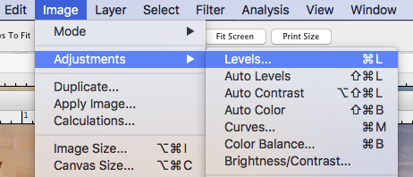

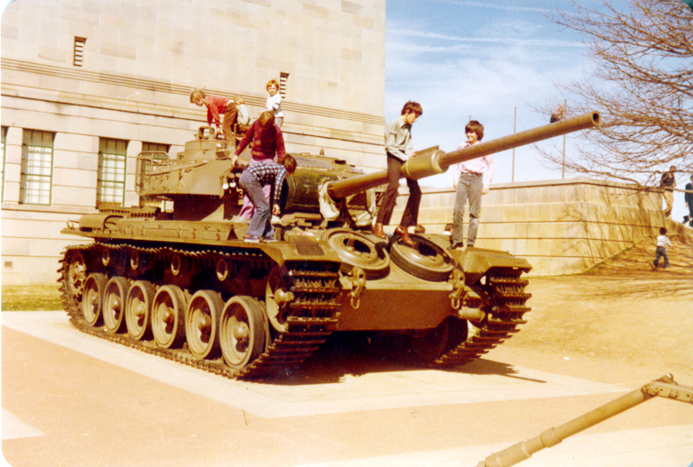

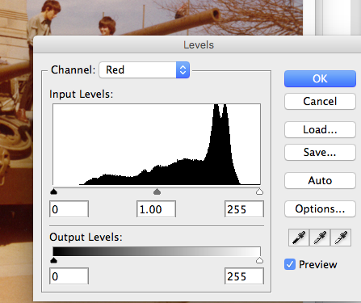
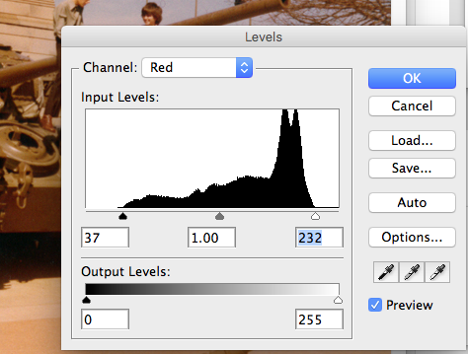

- Remove the background colour of this photograph background girl.jpg so that the image is on a white background
Save the image back onto this document
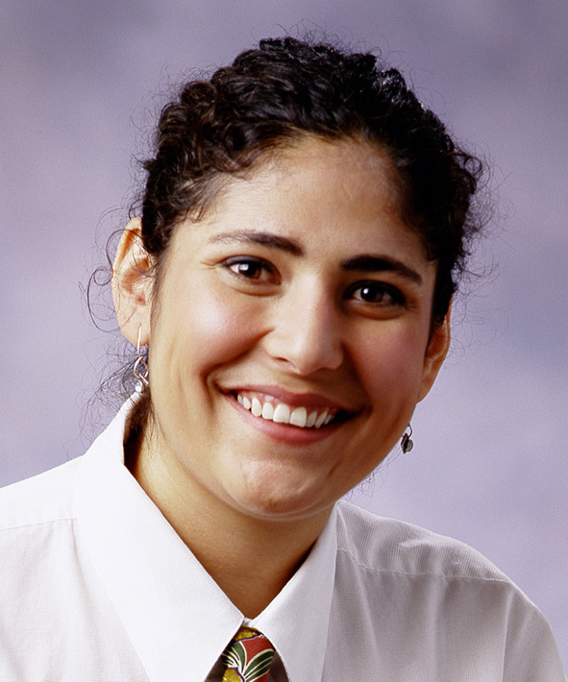

Use the magic wand set to 20 to remove most background, then set wand to 10 and remove remainder, clean up using small eraser
Replace the airborne boy floating boy.jpg, with a picture of the aircraft “air france.jpg” (from MyClasses) ensure you use appropriate scale and size to suit the picture content.
Save the image back onto this document
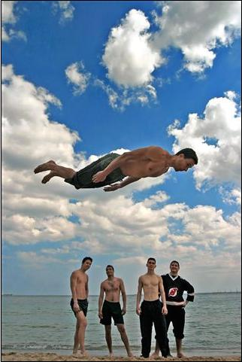

Note if you select another aircraft from the
Internet you will obtain a
higher mark for this.
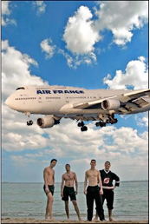

9.The Beijing 2008 logo
Use your graphics package to create a copy of the Beijing 2008 Olympics logo (copy from the internet) or create your own design to be used for the Beijing 2008 Olympics.
Everything in the graphic must be created by you using your graphics package.

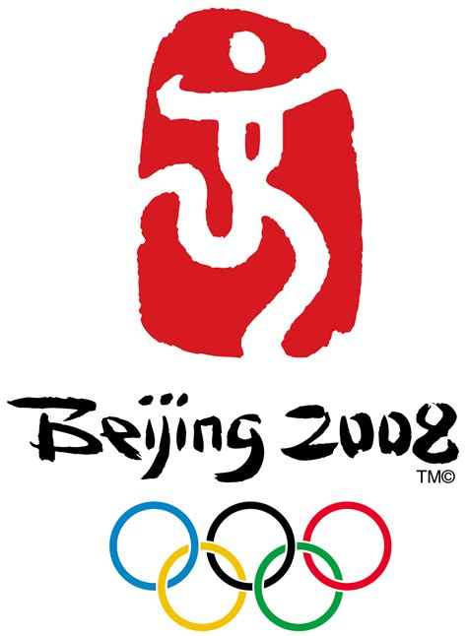

10.Create the Olympic logo using your graphics program in the correct colours and layout, including links. (you must draw this yourself)

The five Olympic rings in correct colour and layout

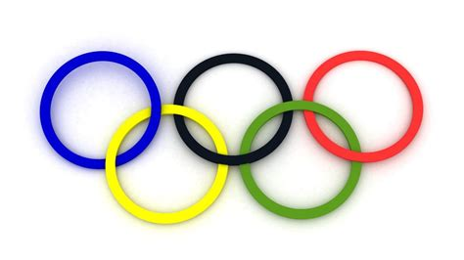

Insert your logo here:

END OF QUESTIONS
Check that you have typed your Student Name on the front cover of this document, and save it to your marking folder

